Assignment 6

**Program 1**

/*Declare a class called logic_gate to represent logic gates.

The class has three data members - input1, input2 and input3

to represent three inputs to the logic gate.

The class also has a virtual function member called get_gate_output.

Derive two classes from the base class logic_gate, namely, and_gate

and or_gate to represent ‘logical and gate’ and ‘logical or gate’

respectively. Define function get_gate_output in both of these

classes to get the output of the gate.

Show use of above classes and functions to demonstrate

dynamic polymorphism in function main.*/

#include<iostream>

#include<conio.h>

using namespace std;

class logic_gate

{

public:

int i1,i2,i3;

void input()

{

cout << "\nInput three binary values: ";

cin >> i1 >> i2 >> i3;

}

virtual void get_gate_output() = 0; // pure virtual

};

class and_gate : public logic_gate

{

public:

void get_gate_output()

{

int o1;

o1 = i1 & i2 & i3;

cout << "\nResult of AND gate : " << o1;

}

};

class or_gate : public logic_gate

{

public:

void get_gate_output()

{

int o2;

o2 = i1 | i2 | i3;

cout << "\nResult of OR gate : " << o2;

}

};

int main()

{

logic_gate *lptr;

and_gate ag;

or_gate og;

lptr = &ag;

lptr -> input();

lptr -> get_gate_output();

lptr = &og;

lptr -> input();

lptr -> get_gate_output();

getch();

return 0;

}

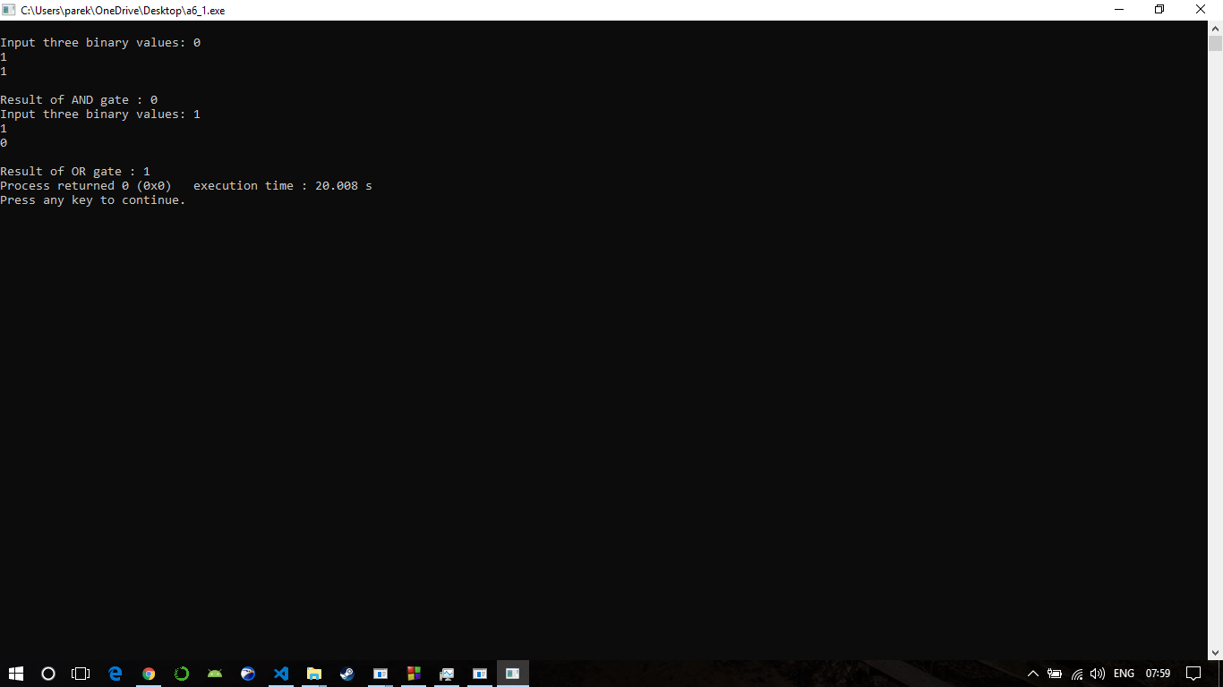

**Program 2**

/*Create class ITEM with item_code, item_rate and

quantity as data members.

Create an array of pointers to objects of class ITEM.

Write a member function which will calculate the

amount of item.

Print item_code and amount of item.*/

#include<iostream>

#include<conio.h>

using namespace std;

class item {

int code;

float rate;

int quantity;

public:

void getdata(int c, float r, int q) {

code = c; rate = r; quantity = q;

}

void calculate() {

rate = quantity * rate;

}

void show() {

cout << "\nCode : " << code << "\n";

cout << "Price: " << rate << "\n";

}

};

const int size = 2;

int main() {

item *p = new item[size];

item *d = p;

int x,z,i;

float y;

//system("cls");

for(i=0; i<size; i++) {

cout << "\nInput code for item " << i+1 << ": ";

cin >> x;

cout << "\nInput price for item " << i+1 << ": ";

cin >> y;

cout << "\nInput quantity for item " << i+1 << ": ";

cin >> z;

p -> getdata(x,y,z);

p++;

}

for(i=0; i<size; i++)

{

cout << "\nTotal price for item " << i+1 << ": ";

d -> calculate();

d -> show();

d++;

}

//getch();

return 0;

}